**VCS Task**

**Task Description:**

Establish a new directory, populate it with script files, initiate an empty repository on GitHub, convert the local directory into a Git repository, and link it to GitHub for pushing the code into the repository.Perform merge, rebase, stash commands in following github repo.

**Step 1: Create a New Directory and Populate It with Script Files**

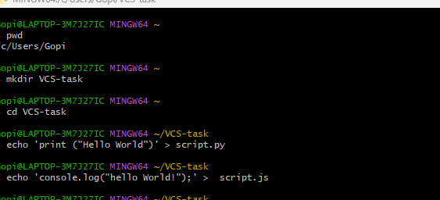

**Step 2: Initialize a Git Repository**

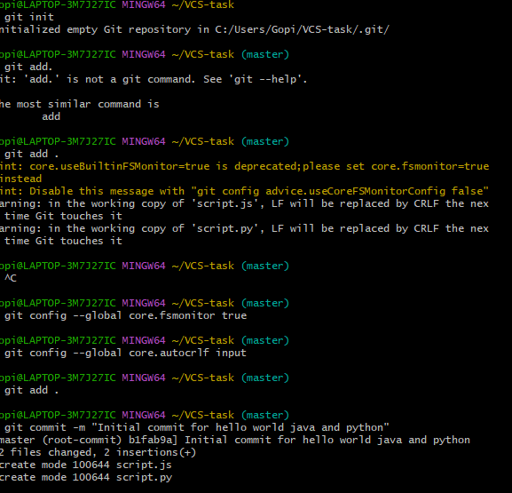

**Step 3: Create an Empty GitHub Repository**

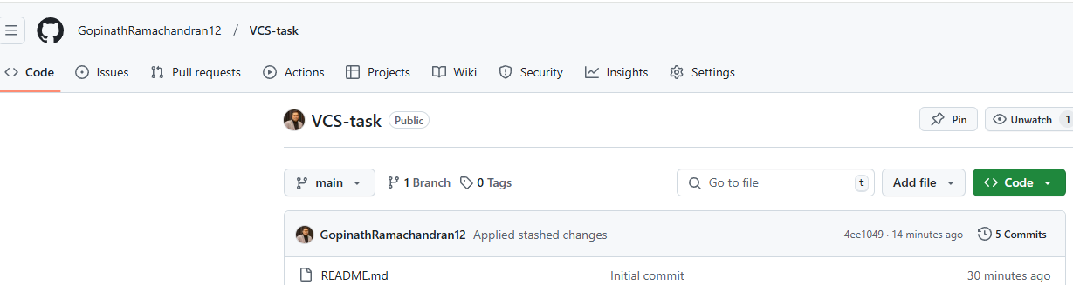

**Step 4: Link Local Repository to GitHub**



**Step 5: Push the Code to GitHub**

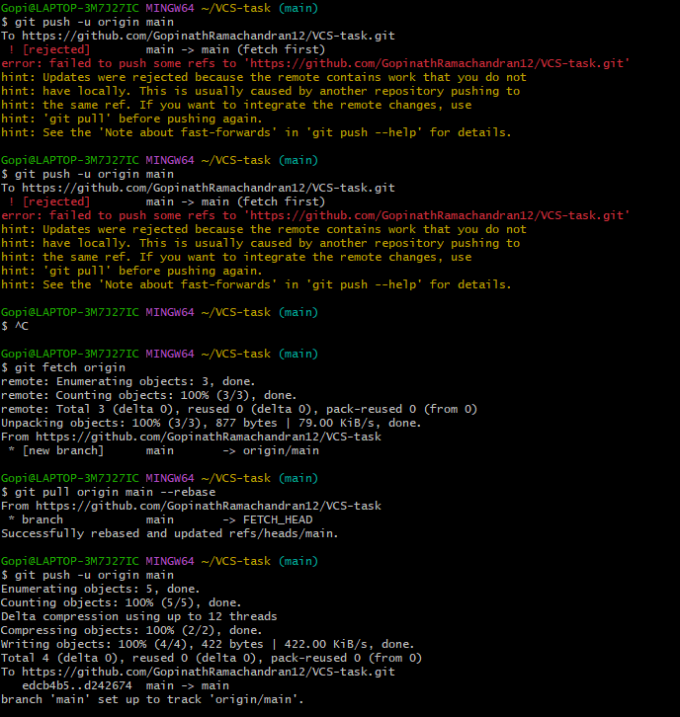

## **Git Merge, Rebase, and Stash Commands in This Repository**

### **1. Creating a New Branch and Merging**

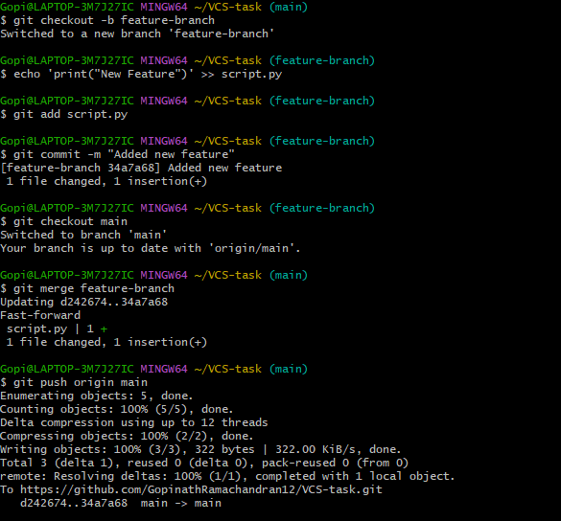

**2. Rebasing a Branch**

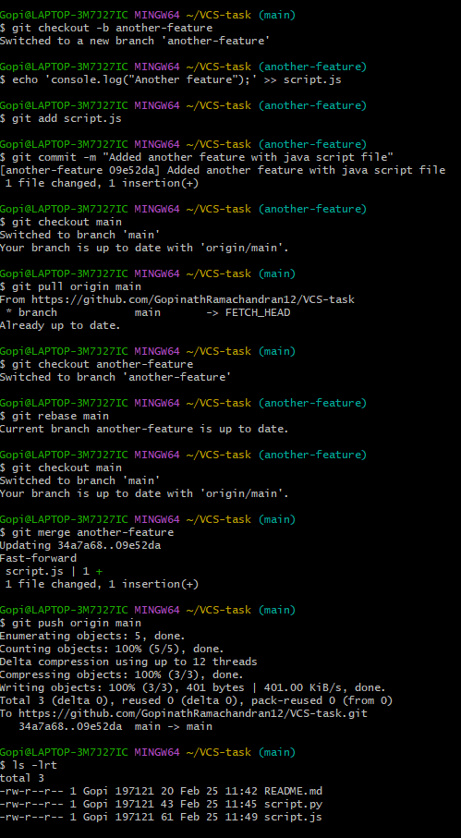

**3. Using Git Stash**

